Locating Metal limited sites with high nutrient and low chlorophyll in USA streams and rivers
Leah Turner
May 6, 2026
Environmental Analysis in R
Background and Introduction
In aquatic ecosystems, high nutrient availability is typically associated with elevated primary productivity, as nutrients such as nitrogen and phosphorus support the growth of phytoplankton and other primary producers. This relationship is evident in many freshwater and coastal systems, where excess nutrient inputs often lead to eutrophication and the formation of harmful algal blooms (HABs). These blooms occur when nutrient concentrations become disproportionately high, causing rapid growth of algae and cyanobacteria. which can disrupt the ecosystem and water quality (Sellner et al. 2003). As a result, nutrient enrichment is commonly viewed as a primary driver of increased biological productivity in aquatic environments.
However, this relationship does not hold across all systems. In certain regions of the world’s oceans, particularly high-nutrient, low-chlorophyll (HNLC) regions, elevated nutrient concentrations do not translate into increased primary productivity. Instead, phytoplankton biomass remains low despite the abundance of nutrients such as nitrates and phosphates. Under typical ecological conditions, high nutrient availability corresponds with high productivity (Baines et al. 2016). This suggests another factor which limits the growth of phytoplankton.
Past research in marine ecosystems has demonstrated that in many HNLC regions, primary productivity is limited by the availability of trace metals, (e.g. Iron, Zinc, Copper, Manganese, and Nickel). Trace metals our essential for key physiological processes such as photosynthesis and nitrogen assimilation. Even when macronutrients are abundant, insufficient concentrations of bioavailable trace metals can restrict phytoplankton growth and prevent an increase in chlorophyll levels (Morel et al. 1991; Sunda and Huntsman 1992). This highlights the importance of micronutrients within ecosystems.
The objective of this project is to determine whether similar HNLC dynamics occur in freshwater systems and if these sites can be identified using data from the United States Environmental Protection Agency (EPA) National Rivers and Streams Assessment and trace metal concentration data compiled by the Powell Center working group
Methods

Data Sources
Data were obtained from the U.S. Environmental Protection Agency (EPA) and the Powell Center working group. EPA datasets included NRSA_1819_Site_Information, NRSA 1819 Water Chemistry_CHLA Data, NRSA_1819_PeriChla, and NRSA_1819_Landscape. Trace metal datasets obtained from the Powell Center working group included Iron_aggregated_high_quality_start2000_cleaned, Manganese_aggregated_high_quality_start2000_cleaned, Nickel_aggregated_high_quality_start2000_cleaned, and Zinc_aggregated_high_quality_start2000_cleaned. Across all eight datasets, there were over 2,000,000 observations and approximately 1,000 variables.

Data Cleaning and Processing
All datasets were filtered to include only observations from 2018 and 2019 for temporal consistency across EPA and metal datasets. Relevant variables were selected from each dataset, including nutrient concentrations, chlorophyll a, site identifiers, and geographic coordinates (see code lines 53–96 for full variable selection). Datasets were merged using shared site identifiers and sampling information to create a unified dataset for analysis.

Definition of HNLC Conditions and Metal Thresholds
High-nutrient, low-chlorophyll (HNLC) conditions were defined using percentile-based thresholds. Within the EPA dataset, “high nutrient” conditions were classified as values in the upper quartile (≥75th percentile) of nutrient concentrations, while “low chlorophyll” conditions were defined as values in the lower quartile (≤25th percentile) of chlorophyll a. Trace metal limitation thresholds were defined based on available literature. Iron (Fe) limitation was defined as concentrations less than 10 µg/L (Larson et al. 2015), manganese (Mn) as less than 1 µg/L(England et al. 2026), nickel (Ni) as less than 1.4 µg/L (McKnight et al. 2023), and zinc (Zn) as less than 5 µg/L (De Schamphelaere and Janssen 2004).

Spatial Analysis
HNLC sites were mapped across the continental United States and categorized by ecoregion to examine broad-scale spatial patterns in nutrient limitation. These visualizations enabled identification of geographic clustering and regional trends in HNLC. To assess relationships between nutrient limitation and trace metal availability, spatial overlap analyses were conducted between HNLC sites and metal concentration datasets. Metal observations were aggregated by location, and overlapping geographic coordinates were used to identify sites where multiple metals (Fe, Mn, Ni, Zn) were present. These overlaps were summarized to determine whether sites exhibited single-metal limitation or co-limitation by multiple trace metals. Additionally, spatial grouping was performed using watershed units (HUC8) and monitoring locations to preserve geographic structure while summarizing nutrient and metal conditions. This approach allowed for comparisons of metal limitation patterns across spatial scales, from individual sampling sites to broader watershed level groupings.

Results
Three primary maps were generated: (1) HNLC sites, (2) metal-limited sites, and (3) the spatial overlap between HNLC and metal-limited sites. The first map (Figure 1) displays the distribution of high-nutrient, low-chlorophyll sites across nine aggregated ecoregions (Eco9). Sites were categorized as high nitrogen (N), high phosphorus (P), or both high N and P. A total of 307 sites met the criteria for HNLC conditions across all ecoregions. Ecoregions were used to account for regional differences in nutrient dynamics. To evaluate whether nutrient and chlorophyll concentrations differed among ecoregions, a Kruskal–Wallis test was performed for chlorophyll (CHLA_Results), nitrogen (NTL_Results), and phosphorus (PTL_Results). All three variables showed significant differences among ecoregions (CHLA: p = 9.483 × 10⁻⁷; NTL: p < 2.2 × 10⁻¹⁶; PTL: p < 2.2 × 10⁻¹⁶). A Dunn post hoc test was subsequently conducted to identify pairwise differences between ecoregions (Figure 2).
The second map (Figure 3) shows the spatial distribution of metal-limited sites across the continental United States. This analysis was primarily exploratory to assess spatial coverage of the metal dataset for 2018–2019. A total of 3,602 sites were identified as limited in at least one of the four metals (Fe, Mn, Ni, Zn), with many sites exhibiting limitation in multiple metals. The final map (Figure 4) represents the spatial overlap between HNLC sites and metal-limited sites. Multiple approaches were tested to align datasets; ultimately, HUC8 watershed units were used as the basis for overlap due to their ecological relevance and compatibility across datasets. Using this method, 259 sites were identified as both HNLC and metal limited. Overall, the project successfully identified and mapped HNLC sites, metal-limited sites, and their spatial intersection across the continental United States.

Discussion
The results indicate that a substantial number of freshwater sites classified as HNLC also exhibit trace metal limitation. This pattern is consistent with observations from marine systems, where HNLC conditions are often associated with limitations in micronutrients such as iron. These findings suggest that trace metal limitation may play an important role in regulating primary productivity in freshwater ecosystems as well. Several limitations should be considered when interpreting these results. First, the metal dataset is still undergoing cleaning and standardization, which may affect the accuracy and completeness of identified metal limited sites. Additionally, spatial coverage of metal data is uneven across the continental United States, with some regions having dense sampling and others having little to no data. This variability likely reflects differences in funding, monitoring priorities, and agency capacity, as well as differences in analytical instrumentation and detection limits.
The spatial overlap analysis also introduces uncertainty. Because datasets did not share identical coordinates or identifiers, HUC8 watershed units were used to approximate overlap between HNLC and metal limited sites. While ecologically meaningful, this approach is less precise than site-level matching and may overestimate or underestimate true overlap. Temporal limitations are also important. This analysis was restricted to data from 2018–2019, meaning that short term environmental conditions (e.g., extreme weather events or regulatory changes) may influence the observed patterns. Expanding the analysis to include additional years would improve strength and help distinguish patterns caused by short term variability.
This project highlights the challenges of integrating datasets from multiple sources, particularly when identifiers and spatial coordinates are not standardized. Differences in formatting, sampling design, and metadata structure required substantial data cleaning and limited the precision of some analyses. Future work should focus on expanding the temporal scope of the analysis, improving spatial matching between datasets, and further refining thresholds for defining metal limitation. Despite these challenges, this study demonstrates a clear approach for identifying HNLC conditions and evaluating their relationship with trace metal availability in freshwater systems.

Conclusion
This study shows that high-nutrient, low-chlorophyll conditions occur in freshwater systems across the continental United States and are often associated with trace metal limitation. By integrating EPA nutrient and chlorophyll data with Powell Center metal datasets, 307 HNLC sites were identified, with 259 also classified as metal limited. These findings suggest that, similar to marine systems, micronutrient availability may play an important role in limiting primary productivity in freshwater ecosystems. Despite limitations related to spatial resolution, dataset compatibility, and the short temporal scope, this study provides a useful framework for identifying HNLC conditions and highlights the importance of considering both macronutrients and trace metals in understanding ecosystem productivity.
Citations
Baines SB et al. 2016. Microplankton trace element contents: implications for mineral limitation of mesozooplankton in an HNLC area. J Plankton Res. 38(2):256–270. https://doi.org/10.1093/plankt/fbv109
De Schamphelaere KAC, Janssen CR. 2004. Bioavailability and Chronic Toxicity of Zinc to Juvenile Rainbow Trout ( Oncorhynchus mykiss ): Comparison with Other Fish Species and Development of a Biotic Ligand Model. Environ Sci Technol. 38(23):6201–6209. https://doi.org/10.1021/es049720m
England H et al. 2026. Timing and method of manganese supplementation effects thermal resilience of Acropora millepora. Biometals. 39(2):667–680. https://doi.org/10.1007/s10534-025-00774-7
Larson CA, Liu H, Passy SI. 2015. Iron supply constrains producer communities in stream ecosystems. FEMS Microbiology Ecology. 91(5) [accessed 2026 May 5]. https://academic.oup.com/femsec/article-lookup/doi/10.1093/femsec/fiv041. https://doi.org/10.1093/femsec/fiv041
McKnight KS et al. 2023. The Effects of Nickel and Copper on Tropical Marine and Freshwater Microalgae Using Single and Multispecies Tests. Environmental Toxicology and Chemistry. 42(4):901–913. https://doi.org/10.1002/etc.5565
Morel FMM, Hudson RJM, Price NM. 1991. Limitation of productivity by trace metals in the sea. Limnol Oceanogr. 36(8):1742–1755. https://doi.org/10.4319/lo.1991.36.8.1742
Sellner KG, Doucette GJ, Kirkpatrick GJ. 2003. Harmful algal blooms: causes, impacts and detection. Journal of Industrial Microbiology and Biotechnology. 30(7):383–406. https://doi.org/10.1007/s10295-003-0074-9
Sunda WG, Huntsman SA. 1992. Feedback interactions between zinc and phytoplankton in seawater. Limnology & Oceanography. 37(1):25–40. https://doi.org/10.4319/lo.1992.37.1.0025

Figures
Figures can better be seen in R markdown document. (HNLC_metal_limitation.html)
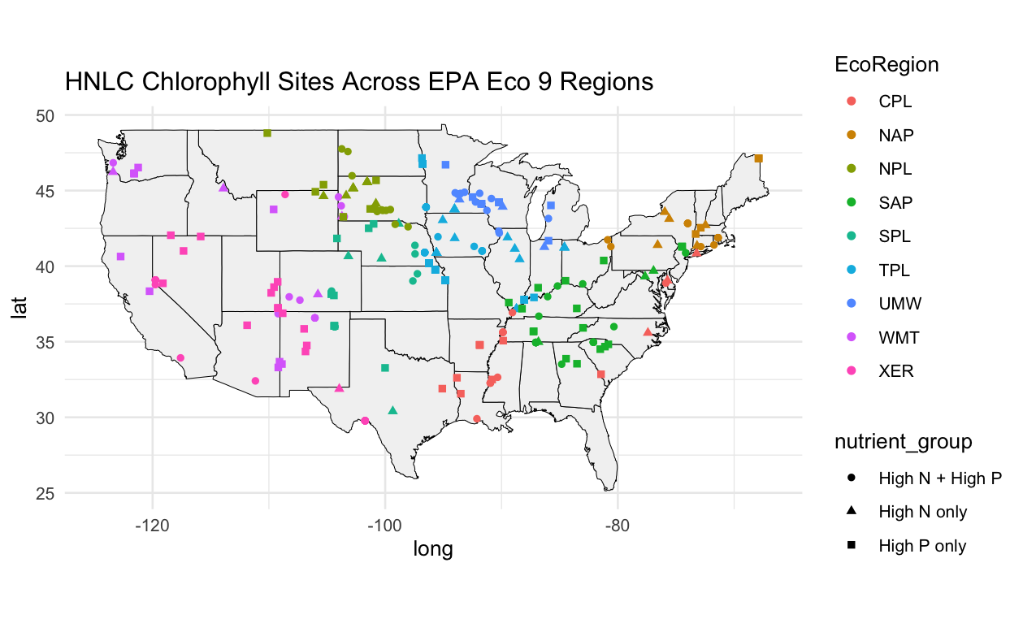
Figure 1: The Distribution of high-nutrient, low-chlorophyll (HNLC) sites across nine aggregated ecoregions (Eco9). Eco regions our indicated by color and nutrient group indicated by shape
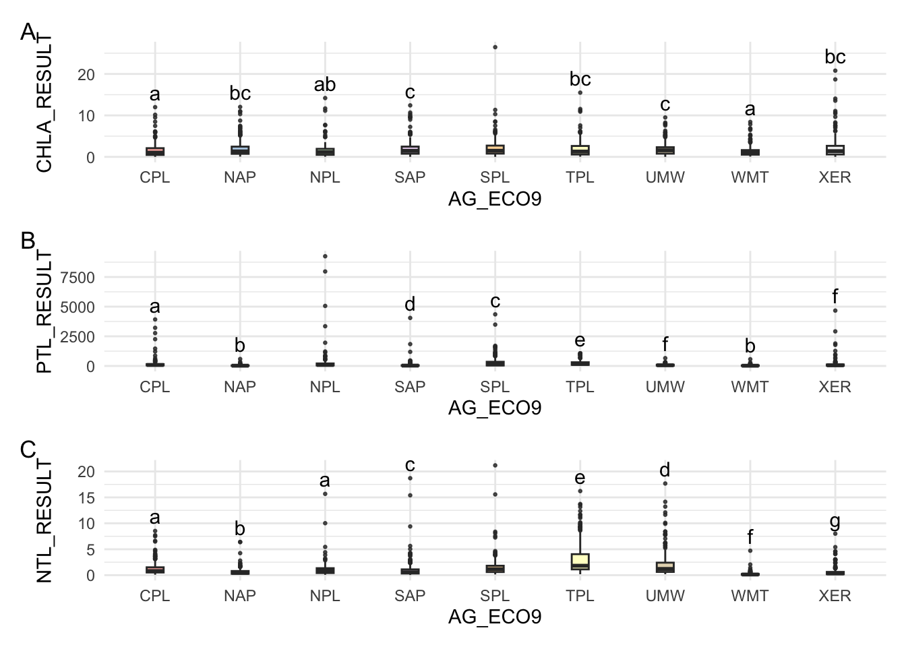
Figure 2: nutrient and chlorophyll concentrations among ecoregions. (A) chlorophyll (CHLA_Results), (B) phosphorus (PTL_Results), and (C) nitrogen (NTL_Results). All three variables showed significant differences among ecoregions (CHLA: p = 9.483 × 10⁻⁷; NTL: p < 2.2 × 10⁻¹⁶; PTL: p < 2.2 × 10⁻¹⁶). Letter indicate significance between regions based on Dunn test.

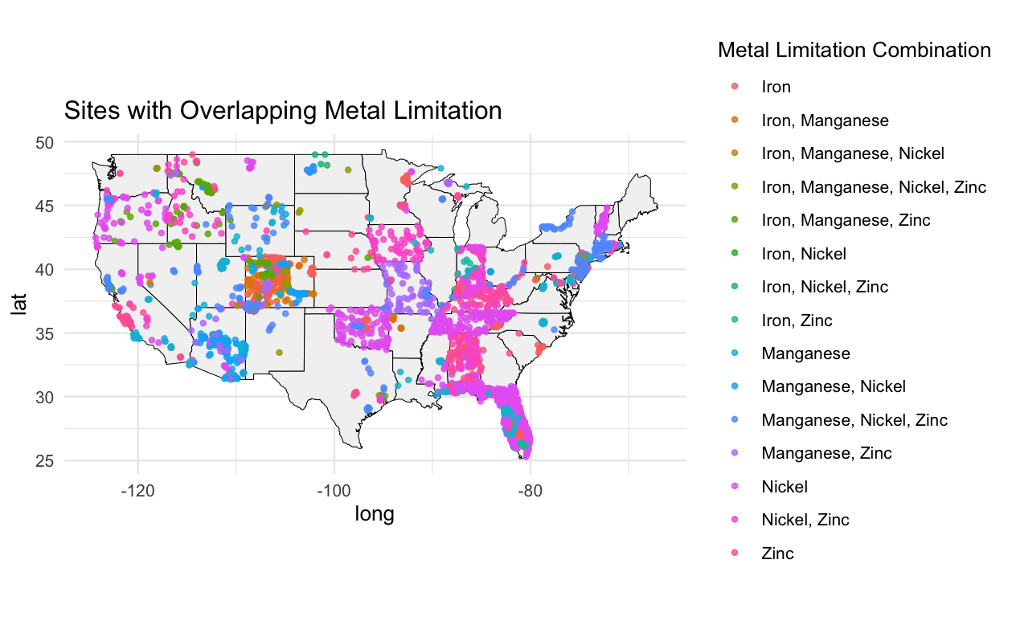
Figure 3: spatial distribution of metal-limited sites across the continental United States. Metal limitation indicated by color of point.
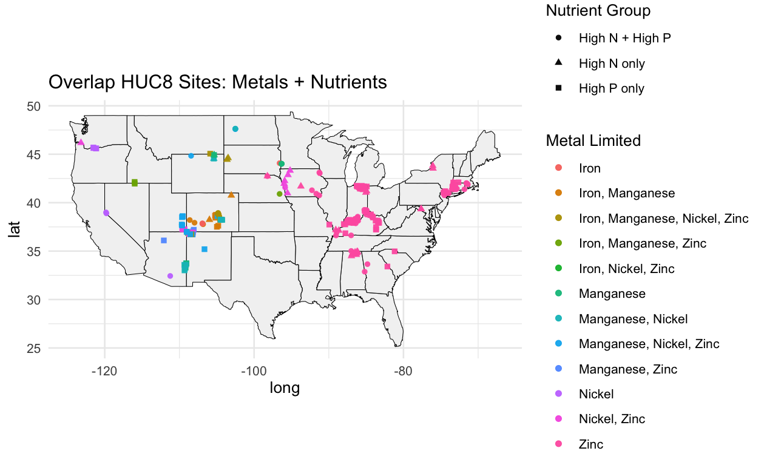
Figure 4: spatial overlap between HNLC sites and metal-limited sites based on HUC 8 watershed code. Nutrient group indicated by shape and Metal limitation indicated by color of point.

Additional Information
GitHub final project link
Organized and complete R markdown code
HNLC_metal_limitation.Rmd
Additional R code (not cleaned but more working through the process, includes things attempts at overlapping data in different ways/ data exploration)
Clean HNLC data.R
EPA_RandS.R
Final_project_Turner.R
Metal Data.R
Due to size of metal data, it is located in data.zip file on GitHub repository

